**Project Design Phase-II**

**Technology Stack (Architecture & Stack)**

|  |  |
| --- | --- |
| Date | 03 October 2022 |
| Team ID | PNT2022TMID50823 |
| Project Name | IOT based smart crop protection system for agriculture |
| Maximum Marks | 4 Marks |

**Technical Architecture:**

The Deliverable shall include the architectural diagram as below and the information as per the table1 & table 2

**Example: Order processing during pandemics for offline mode**

**Reference:** [**https://developer.ibm.com/patterns/ai-powered-backend-system-for-order-processing-during-pandemics/**](https://developer.ibm.com/patterns/ai-powered-backend-system-for-order-processing-during-pandemics/)

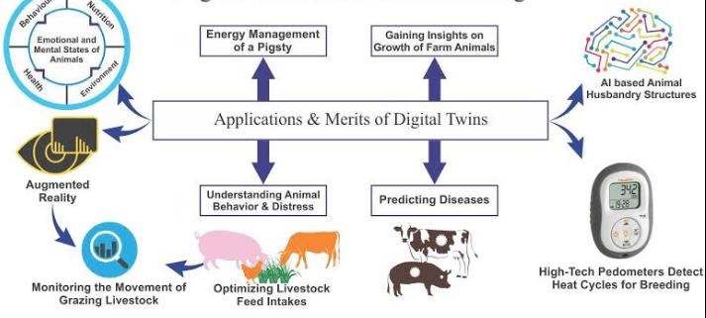

Guidelines:

This system uses a motion sensor to detect wild animals approaching near the field. In such a case the sensor signals the microcontroller to take action.

The microcontroller now sounds an alarm to woo the animals away from the field as well as sends sms to the farmer so that he may know about the issue and come to the spot in case the animals don’t turn away by the alarm.

The microcontroller now sounds an alarm to woo the animals away from the field as well as sends sms to the farmer so that he may know about the issue and come to the spot in case the animals don’t turn away by the alarm.

**Table-1 : Components & Technologies:**

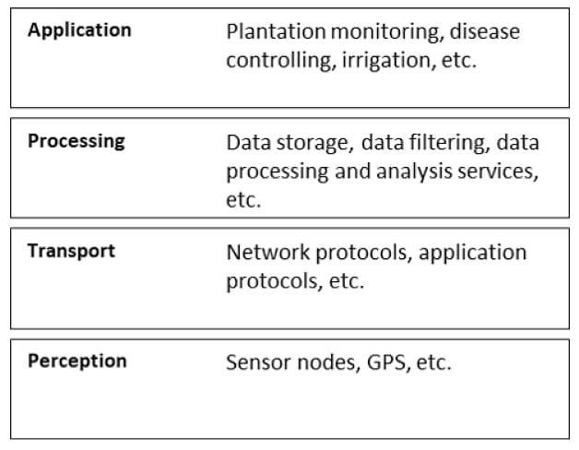

**Table-2: Application Characteristics:**

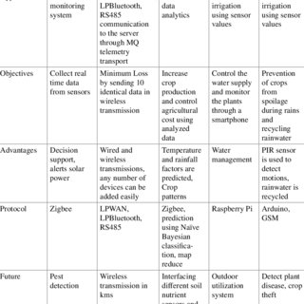

**References:**

**https://article.murata.com/en-euarticle/measure=against-wildife-damage-through-iot**

**https://www.fao.org/3/cb244en/cb2447en.pdf**